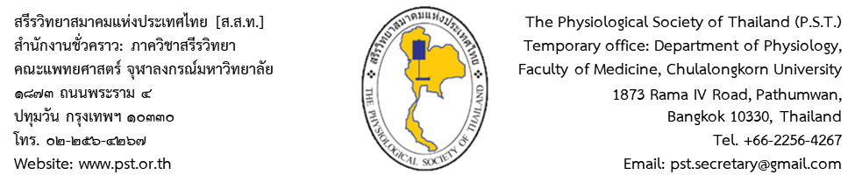

Approved by the PST
Executive Committee
on ……………………..

Please
attach a recent photo

LIFETIME MEMBERSHIP APPLICATION
The Physiological Society of Thailand
Membership No.

1. Name
ค่าสมาชิกตลอดชีพ 1,500 บาท
กรุณาโอนเข้า บัญชีออมทรัพย์ ธนาคารไทยพาณิชย์ สาขาศิริราช เลขที่ 016-4-16480-1
ชื่อบัญชี สรีรวิทยาสมาคมแห่งประเทศไทย
โปรดส่งใบสมัครพร้อมหลักฐานการโอนเงินทาง e-mail: pst.secretary@gmail.com หรือ
ทางไปรษณีย์: นายทะเบียน สรีรวิทยาสมาคมแห่งประเทศไทย ภาควิชาสรีรวิทยา คณะแพทยศาสตร์ศิริราชพยาบาล มหาวิทยาลัยมหิดล บางกอกน้อย กรุงเทพมหานคร 10700
2. Academic position
3. Highest degree attained
4. Expertise

5. Birth date Age yr.
6. Office address
Tel.: Fax.:
7. Alternative contact address
Tel.: Fax.:
8. E-mail
9. Preferred postal address: [ ] Office (6) [ ] Alternative contact (7)

I hereby certify that the above information is true and correct.

Applicant’s signature
Date

Lifetime membership fee 1,500 baht, to be paid by money transfer to:
Account name: Physiological Society of Thailand / Savings Account No. 016-4-16480-1
Bank name: The Siam Commercial Bank Company Limited / Branch: Siriraj Branch
Address: 2 Wanglang Rd., Siriraj, Bangkoknoi, Bangkok 10700, Thailand. SWIFT CODE: SICOTHBK

Please send this completed form together with the transfer receipt via e-mail or post.
E-mail: pst.secretary@gmail.com / Post: Secretary General, Physiological Society of Thailand,
c/o Department of Physiology, Faculty of Medicine, Chulalongkorn University, 1873 Rama IV Road, Pathumwan, Bangkok 10330, THAILAND.

